 |  |  |  | 9AM STARS (CWL)  9AM Coral Springs Café (GBD)  10AM Early Bird Bingo (GBD)  1PM 1:1 Visits  1:30PM STARS (CWL)  2PM Rosary (GBD)  2:30PM Exercising (GBD)  3PM Manicures (GBD)  4PM Wacky Wordies (GBD)  7PM Bocce Ball (GBD) | 9AM STARS (CWL)  9AM Coral Springs Café (GBD)  10AM Daily Chronicles (GBD)  10:30AM Music (GBD)  1PM 1:1 Visits  1:30PM STARS (CWL)  2PM Happy Hour (GBD)  3PM Men’s Group (GBD)  4PM Remembering Family Sundays (GBD)  7PM Bowling (GBD) | 9AM Coral Springs Café (GBD)  10AM Daily Chronicles (GBD)  10:30AM Music (GBD)  1PM 1:1 Visits  1:30PM STARS (CWL)  2PM Joker’s Wild (GBD)  3PM Color by Number (GBD)  4PM You be the Judge (GBD)  7PM Movie Night (GBD)
9AM Coral Springs Café (GBD)  10AM Daily Chronicles (GBD)  10:30AM Gospel Music (GBD)  1PM 1:1 Visits  1:30PM STARS (CWL)  2PM Po-Ke-No (GBD)  3PM New Fellowship Church (GBD)  4PM Finish the Lyrics (GBD)  7PM Hangman (GBD) | 9AM STARS (CWL)  9AM Coral Springs Café (GBD)  10AM Dailly Chronicles (GBD)  1PM 1:1 Visits  1:30PM STARS (CWL)  2PM Cooking Club (GBD)  2:30PM Arts & Crafts (GBD)  3:30PM Who Am I (GBD)  4PM Board Games (GBD)  7PM Bingo (GBD) | 9AM STARS (CWL)  9AM Coral Springs Café (GBD)  10AM Bible Study (GBD)  10:30AM Music (GBD)  1PM 1:1 Visits  1:30PM STARS (CWL)  2PM Floral Arrangements (GBD)  3:30PM Mix Master (CY)  4PM Coffee and Doughnuts Detective (GBD)  7PM Trivia (GBD) | 9AM STARS (CWL)  9AM Coral Springs Café (GBD)  10AM Daily Chronicles (GBD)  10:30AM Concentration Puzzle (GBD)  1PM 1:1 Visits  1:30PM STARS (CWL)  2PM Arts & Crafts (GBD)  3:30PM Kickball (CY)  7PM Ice Cream Social (GBD) | 9AM STARS (CWL)  9AM Coral Springs Café (GBD)  10AM Early Bird Bingo (GBD)  1PM 1:1 Visits  1:30PM STARS (CWL)  2PM Rosary (GBD)  2:30PM Exercising (GBD)  3PM Manicures (GBD)  4PM Wacky Wordies (GBD)  7PM Card Games (GBD) | 9AM STARS (CWL)  9AM Coral Springs Café (GBD)  10AM Daily Chronicles (GBD)  10:30AM Music (GBD)  1PM 1:1 Visits  1:30PM STARS (CWL)  2PM Happy Hour (GBD)  3PM Women’s Group (GBD)  4PM Short Story (GBD)  7PM Bowling (GBD) | 9AM Coral Springs Café (GBD)  10AM Daily Chronicles (GBD)  10:30AM Music (GBD)  1PM 1:1 Visits  1:30PM STARS (CWL)  2PM Joker’s Wild (GBD)  3PM Color by Number (GBD)  4PM You be the Judge (GBD)  7PM Movie Night (GBD)
9AM Coral Springs Café (GBD)  10AM Daily Chronicles (GBD)  10:30AM Gospel Music (GBD)  1PM 1:1 Visits  1:30PM STARS (CWL)  2PM Po-Ke-No (GBD)  3PM Reminiscing (CY)  4PM Mind Joggers (GBD)  7PM Hangman (GBD) | 9AM STARS (CWL)  9AM Coral Springs Café (GBD)  10AM Daily Chronicles (GBD)  1PM 1:1 Visits  1:30PM STARS (CWL)  2PM Cooking Club (GBD)  2:30PM Arts & Crafts (GBD)  3:30PM Yard Games (Cy)  4:30PMWhat Am I (Cy)  7PM Bingo (GBD) | 9AM STARS (CWL)  9AM Coral Springs Café (GBD)  10AM Bible Study (GBD)  10:30AM Music (GBD)  1PM 1:1 Visits  1:30PM STARS (CWL)  2PM Resident’s Council (GBD)  3:00PM Floral Arrangements (GBD)  4PM Puzzles (GBD)  7PM Trivia (GBD) | 9AM STARS (CWL)  9AM Coral Springs Café (GBD)  10AM Daily Let’s Celebrate Flag Day (GBD)  10:30AM Concentration Puzzle (GBD)  1PM 1:1 Visits  1:30PM STARS (CWL)  2PM Arts & Crafts (GBD)  3:30PM Flag Day Trivia (CY)  4PM Kickball (CY)  7PM Ice Cream Social (GBD) | 9AM STARS (CWL)  9AM Coral Springs Café (GBD)  10AM Early Bird Bingo (GBD)  1PM 1:1 Visits  1:30PM STARS (CWL)  2PM Rosary (GBD)  2:30PM Exercising (GBD)  3PM Manicures (GBD)  4PM Wacky Wordies (GBD)  7PM Bocce Ball (GBD) | 9AM STARS (CWL)  9AM Coral Springs Café (GBD)  10AM Daily Chronicles (GBD)  10:30AM Music (GBD)  1PM 1:1 Visits  1:30PM STARS (CWL)  2PM Happy Hour (GBD)  3PM Men’s Group (GBD)  4PM The Cultivation of Fairies (GBD)  7PM Bowling (GBD) | 9AM STARS (CWL)  9AM Coral Springs Café (GBD)  10AM Daily Chronicles (GBD)  10:30AM Music (GBD)  1PM 1:1 Visits  1:30PM STARS (CWL)  2PM Planting a Seed (GBD)  3PM You be the Judge (GBD)  4PM Color by Number (GBD)  7PM Movie Night (GBD)
9AM Coral Springs Café (GBD)  10AM Daily Chronicles (GBD)  10:30AM Gospel Music (GBD)  1PM 1:1 Visits  1:30PM STARS (CWL)  2PM Father’s Day Social (CY)  3PM Fatherly Wit and Wisdom (GBD)  4PM Detective (GBD)  7PM Hangman (GBD) | 9AM STARS (CWL)  9AM Coral Springs Café (GBD)  10AM A Celebration of Freedom (GBD)  1PM 1:1 Visits  1:30PM STARS (CWL)  2PM Miss Juneteenth (GBD)  2:30PM Arts & Crafts (GBD)  3:30PM Juneteenth True or False (GBD)  4PM Board Games (GBD)  7PM Bingo (GBD) | 9AM STARS (CWL)  9AM Coral Springs Café (GBD)  10AM Bible Study (GBD)  10:30AM Music from the 50’s (GBD)  1PM 1:1 Visits  1:30PM STARS (CWL)  2PM Food Services Meeting (GBD)  2:30PM Floral Arrangements (GBD)  3:30PM Yard Games (CY)  4PM Who am I (GBD)  7PM Trivia (GBD) | 9AM STARS (CWL)  9AM Coral Springs Café (GBD)  10AM Daily Chronicles (GBD)  10:30AM Concentration Puzzle (GBD)  1PM 1:1 Visits  1:30PM STARS (CWL)  2PM Arts & Crafts (GBD)  3:30PM Kickball (CY)  7PM Ice Cream Social (GBD) | 9AM STARS (CWL)  9AM Coral Springs Café (GBD)  10AM Early Bird Bingo (GBD)  1PM 1:1 Visits  1:30PM STARS (CWL)  2PM Rosary (GBD)  2:30PM Exercising (GBD)  3PM Manicures (GBD)  4PM Wacky Wordies (GBD)  7PM Card Games (GBD) | 9AM STARS (CWL)  9AM Coral Springs Café (GBD)  10AM Daily Chronicles (GBD)  10:30AM Music (GBD)  1PM 1:1 Visits  1:30PM STARS (CWL)  2PM Happy Hour (GBD)  3PM Women’s Group (GBD)  4PM Short Story (GBD)  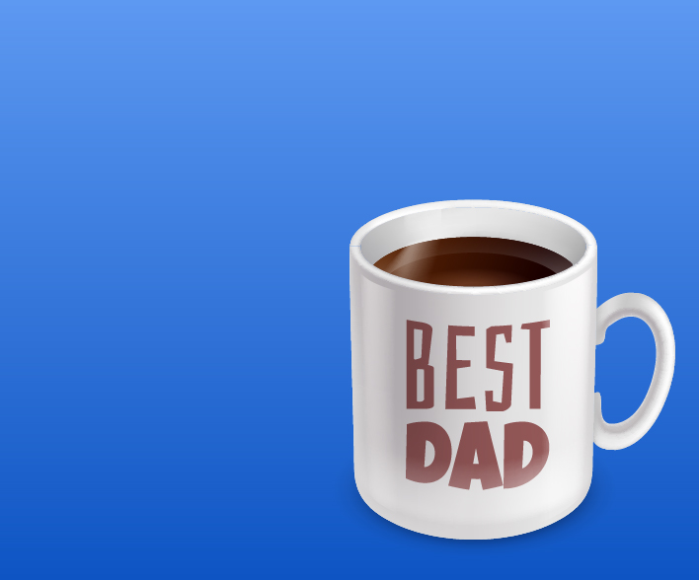  7PM Bowling (GBD) | 9AM Coral Springs Café (GBD)  10AM Daily Chronicles (GBD)  10:30AM Music (GBD)  1PM 1:1 Visits  1:30PM STARS (CWL)  2PM Joker’s Wild (GBD)  3PM Healing for your Soul (GBD)  4PM You be the Judge (GBD)  7PM Movie Night (GBD)
9AM Coral Springs Café (GBD)  10AM Daily Chronicles (GBD)  10:30AM Gospel Music (GBD)  1PM 1:1 Visits  1:30PM STARS (CWL)  2PM Po-Ke-No (GBD)  3PM Reminiscing (CY)  4PM Humor (GBD)  7PM Hangman (GBD) | 9AM STARS (CWL)  9AM Coral Springs Café (GBD)  10AM History of the Tuba (GBD)  1PM 1:1 Visits  1:30PM STARS (CWL)  2PM Cooking Club (GBD)  2:30PM Arts & Crafts (GBD)  3:30PM Yard Games (CY)  4:30PM What Am I (CY)  7PM Bingo (GBD) | 9AM STARS (CWL)  9AM Coral Springs Café (GBD)  10AM Bible Study (GBD)  10:30AM Music (GBD)  1PM 1:1 Visits  1:30PM STARS (CWL)  2PM Floral Arrangements (GBD)  3:30PM Mix Master (CY)  4PM Puzzles (GBD)  7PM Trivia (GBD) | 9AM STARS (CWL)  9AM Coral Springs Café (GBD)  10AM Daily Chronicles (GBD)  10:30AM Concentration Puzzle (GBD)  1PM 1:1 Visits  1:30PM STARS (CWL)  2PM Arts & Crafts (GBD)  3:30PM Kickball (CY)  7PM Ice Cream Social (GBD) | 9AM STARS (CWL)  9AM Coral Springs Café (GBD)  10AM Early Bird Bingo (GBD)  1PM 1:1 Visits  1:30PM STARS (CWL)  2PM Rosary (GBD)  2:30PM Exercising (GBD)  3PM Manicures (GBD)  4PM Wacky Wordies (GBD)  7PM Bocce Ball (GBD) | 9AM STARS (CWL)  9AM Coral Springs Café (GBD)  10AM Daily Chronicles (GBD)  10:30AM Music (GBD)  1PM 1:1 Visits  1:30PM STARS (CWL)  2PM Happy Hour (GBD)  3PM Men’s Group (GBD)  4PM Remembering Wedding Songs (GBD)  7PM Bowling (GBD)

Coral Springs Rehab. & Healthcare Center 505 Greenbank Road, Wilmington, Delaware 19808 (302) 998-0101
Sunday | Monday | Tuesday | Wednesday | Thursday | Friday | Saturday
 |  |  |  | 1 | 2 | 3
4 | 5 | 6 | 7 | 8 | 9 | 10
11 | 12 | 13 | 14  Flag Day (US) | 15 | 16 | 17
18  Father’s Day | 19  Juneteenth | 20 | 21  Summer Begins | 22 | 23 | 24
25 | 26 | 27 | 28 | 29 | 30

