Sunday | Monday | Tuesday | Wednesday | Thursday | Friday | Saturday
 |  |  |  |  |  | 1
2 | 3 | 4  Mardi Gras | 5 | 6 | 7 | 8
9  Daylight Saving Time Begins | 10 | 11 | 12 | 13  Purim Begins | 14 | 15
16 | 17  St. Patrick’s Day | 18 | 19 | 20  Spring Begins | 21 | 22
23 | 24 | 25 | 26 | 27 | 28 | 29
30 | 31

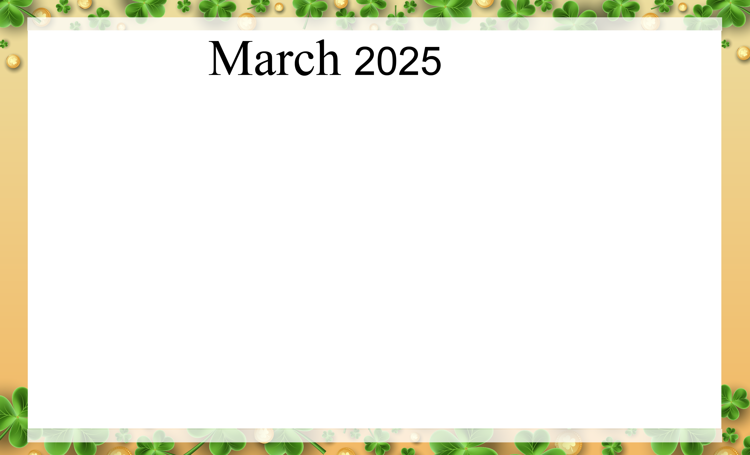  Coral Springs |  |  |  |  |  | 9AM Coral Springs Café (ED)  9AM STARS  10AM Daily Chronicles (ED)  10:30AM Word Games (ED)  1PM 1:1 Visit  1PM STARS (CWL)  2PM Po-Ke-No (ED)  3PM Arts & Crafts (ED)  7PM Dominoes (ED)
9AM Coral Springs Café (ED)  9AM STARS (CWL  10AM Daily Chronicles (ED)  10:30AM Gospel Music (ED)  1PM STARS (CWL)  1PM 1:1 Visits  2PM Religious Crafts (ED)  3PM New Fellowship Church (ED)  3:30PM Finish the Song lyric (ED)  7PM Hang Man (ED) | 9AM STARS (CWL)  9AM Coral Springs Café (ED)  10AM St James (ED)  10:30AM Daily Chronicles (ED)  1PM 1:1 Visits  1PM STARS (CWL)  2PM Cooking Club (ED)  2:30PM Arts & Crafts (ED)  4PM What Am I (ED)  7PM Bingo (ED) | 9AM STARS (CWL)  9AM Coral Springs Café (ED)  10AM Bible Study (ED)  10:30AM Daily Chronicles (ED)  1PM 1:1 Visits  1PM STARS (CWL)  2PM Fat Tuesday Fill-In (ED)  2:30 Mardi Gras Celebration (ED)  3:00PM Game (ED)  4PM Outside Activity (CY)  7PM Trivia (ED) | 9AM STARS (CWL)  9AM Coral Springs Café (ED)  10AM Daily Chronicles (ED)  10:30AM Concentration Puzzle (ED)  1PM 1:1 Visits  1PM STARS (CWL)  2PM Arts & Crafts (ED)  4PM Reminiscing (ED)  7PM Ice Cream Social (ED) | 9AM STARS (CWL)  9AM Coral Springs Café (ED)  10AM Early Bird Bingo (ED)  1PM 1:1 Visits  1PM STARS (CWL)  2PM Rosary (ED)  2:30 Dance Workout (ED)  3PM Manicures (ED)  4PM Wacky Wordies (ED)  7PM Movie Night (ED) | 9AM STARS (CWL)  9AM Coral Springs Café (ED)  10AM Daily Chronicles (ED)  10:30AM Trivia (ED)  1PM 1:1 Visits  1PM STARS (CWL)  2PM Happy Hour (ED)  3PM Women’s Group (ED)  3:30PM Outside (CY)  7PM Game Night (ED) | 9AM Coral Springs Café (ED)  9AM STARS (CWL)  10AM Daily Chronicles (ED)  10:30AM Word Games (ED)  1PM 1:1 Visit  1PM STARS (CWL)  2PM Po-Ke-No (ED)  3PM Paint by Numbers (ED)  3:30PM Bowling (ED)  7PM Dominoes (ED)
9AM Coral Springs Café (ED)  9AM STARS (CWL)  10AM Daily Chronicles (ED)  10:30AM (ED)  1PM 1:1 Visits  1PM STARS (CWL)  2PM Bible Study (ED)  3PM Guess the Movie by the Song (ED)  7PM Hangman (ED) | 9AM STARS (CWL)  9AM Coral Springs Café (ED)  10AM Daily Chronicles (ED)  10:30AM Word Games (ED)  1PM 1:1 Visits  1PM STARS (CWL)  2PM Cooking Club (ED)  2:30PM Arts & Crafts (ED)  3:30PM Outside Activities (CY)  4PM Where Am I (ED)  7PM Bingo (ED) | 9AM STARS (CWL)  9AM Coral Springs Café (ED)  10AM Bible Study (ED)  10:30AM Daily Chronicles (ED)  1PM 1:1 Visits  1PM STARS (CWL)  2PM Resident Council Meeting (ED)  3:00PM Movie Character Guess Who (ED)  7PM Trivia (ED) | 9AM STARS (CWL)  9AM Coral Café (ED)  10AM Daily Chronicles (ED)  10:30AM Concentration Puzzle (ED)  1PM 1:1 Visits  1PM STARS (CWL)  2PM Arts & Crafts (ED)  3:30PM Outside Activities (CY)  4PM Parachutes (ED)  7PM Ice Cream Social (ED) | 9AM STARS (CWL)  9AM Coral Springs Café (ED)  10AM Early Bird Bingo (ED)  1PM 1:1 Visits  1PM STARS (CWL)  2PM Rosary (ED)  2:30PM Chair Yoga (ED)  3PM Spa Day (ED)  4PM Story of Joyous Purim (ED)  7PM Movie Night (ED) | 9AM STARS (CWL)  9AM Coral Springs Café (ED)  10AM Daily Chronicles (ED)  10:30AMCaravan of Camels (ED)  1PM 1:1 Visits  1PM STARS (CWL)  2PM Happy Hour with Bob (ED)  3PM EZ Adapted Charades (ED)  3:30PM Short Story (ED)  7PM Puzzles (ED) | 9AM Coral Springs Café (ED)  9AM STARS (CWL)  10AM Daily Chronicles (ED)  10:30AM Word Games (ED)  1PM 1:1 Visits  2PM Saturday Matinee (ED)  7PM Dominoes (ED)
9AM Coral Springs Café (ED)  9AM STARS (CWL)  10AM Daily Chronicles (ED)  10:30AM Gospel Music (ED)  1PM 1:1 Visits  1PM STARS (CWL)  2PM Bible Study (ED)  2:30PM St Patrick’s Day Riddles (ED)  3:30PM Green & Gold Detective (ED)  7PM Hang Man (ED) | 9AM STARS (CWL)  9AM Coral Springs Café (ED)  10AMSt James Church (ED)  10:30AM St Patrick’s Day (ED)  1PM 1:1 Visits  1PM STARS (CWL)  2PM St Paddy’s Search Games (ED)  2:30PM St Patrick’s Day Celebration (ED)  3:30PM True or Blarney (ED)  7PM Bingo (ED) | 9AM STARS (CWL)  9AM Coral Springs Café (ED)  10AM Bible Study (ED)  10:30AM Daily Chronicles (ED)  1PM 1:1 Visits  1PM STARS (CWL)  2:00PM Food Council Meeting (ED)  2:30PM Games (ED)  3:30PM Outside Activities (CY)  7PM Trivia (ED) | 9AM STARS (CWL)  9AM Coral Springs Café (ED)  10AM Daily Chronicles (ED)  10:30AM Concentration Puzzle (ED)  1PM 1:1 Visits  1PM STARS (CWL)  2PM Arts & Craft (ED)  3:30PM March IQ (ED)  7PM Ice Cream Social (ED) | 9AM STARS (CWL)  9AM Coral Springs Café (ED)  10AM Early Bird Bingo (ED)  1PM 1:1 Visits  1PM STARS (CWL)  2PM Rosary (ED)  2:30PM Moving & Grooving (ED)  3PM Spa Day (ED)  4PM Wacky Wordies (ED)  7PM Movie Night (ED) | 9AM STARS (CWL)  9AM Coral Springs Café (ED)  10AM Daily Chronicles (ED)  10:30AM February (ED)  1PM 1:1 Visits  1PM STARS (CWL)  2PM Happy Hour (ED)  3PM Men’s Group (ED)  3:30PM Outside (CY)  7PM Game Night (ED) | 9AM Coral Springs Café (ED)  9AM STARS (CWL)  10AM Daily Chronicles (ED)  10:30AM Word Games (ED)  1PM 1:1 Visits  1PM STARS (CWL)  2PM Po-Ke-No (ED)  3PM Planting a Seed Church (ED)  4PM Ticklish Trivia Game (ED)  7PM Dominoes (ED)
9AM Coral Springs Café (ED)  9AM STARS (CWL)  10AM Daily Chronicles (ED)  10:30AM Gospel Music (ED)  1PM STARS (CWL)  1PM 1:1 Visits  2PM Bible Trivia (ED)  3PM Puzzles (ED)  7PM Hangman (ED) | 9AM STARS (CWL)  9AM Coral Springs Café (ED)  10AM Daily Chronicles (ED)  10:30AM (ED)  1PM 1:1 Visits  1PM STARS (CWL)  2pm Cooking Club (ED)  3PM Arts & Crafts (ED)  4PM Who Am I (ED)  7PM Bingo (ED) | 9AM STARS (CWL)  9AM Coral Springs Café (ED)  10AM Bible Study (ED)  10:30AM Daily Chronicles (ED)  1PM 1:1 Visits  1PM STARS (CWL)  2:00PM Mix Masters (ED)  2:30PM Team Spelling Bee (ED)  3:30PM Wacky Wordies (ED)  7PM Trivia (ED) | 9AM STARS (CWL)  9AM Coral Springs Café (ED)  10AM Daily Chronicles (ED)  10:30AM Concentration Puzzle D)  1PM 1:1 Visits  1PM STARS (CWL)  2PM Arts & Crafts (ED)  3PM Movie Character (ED)  4PM Outside Activities (CY)  7PM Ice Cream Social (ED) | 9AM STARS (CWL)  9AM Coral Springs Café (ED)  10AM Early Bird Bingo (ED)  1PM 1:1 Visits  1PM STARS (CWL)  2PM Rosary (ED)  2:30 Moving & Grooving (ED)  3PM Manicures (ED)  4PM Wacky Wordies (ED)  7PM Movie Night (ED) | 9AM STARS (CWL)  9AM Coral Springs Café (ED)  10AM Daily Chronicles (ED)  10:30AM Pondering Prompts (ED)  1PM 1:1 Visits  1PM STARS (CWL)  2PM Birthday Bash with Bob (ED)  3PM What Am I (ED)  3:30PM Shorty Story (ED)  7PM (ED) Puzzles (ED) | 9AM Coral Springs Café (ED)  9AM STARS (CWL)  10AM Daily Chronicles (ED)  10:30AM Word Games (ED)  1PM 1:1 Visit  1PM STARS (CWL)  2PM Po-Ke-No (ED)  3PM Paint by Numbers (ED)  3:30PM Bowling (ED)  7PM Dominoes (ED)
9AM STARS (ED)  9AM Coral Springs Café (ED)  10AM Daily Chronicles (ED)  10:30AM Collage Detective (ED)  1PM Stars (CWL)  1PM 1:1 Visits  2PM Card/Board Games (ED)  3PM Outside Activities (ED)  7PM Hangman (ED) | 9AM STARS (CWL)  9AM Coral Springs Café (ED)  10AM St James (ED)  10:30AM Spring Road Trip Detective (ED)  1PM 1:1 Visits  1PM STARS (CWL)  2PMArts & Crafts (ED)  3:30PM What Am I (ED)  4PMPuzzles (ED)  7PM Bingo (ED)
Coral Springs Rehab & Healthcare Center 505 Greenbank Road Wilmington Delaware 19808 (302)998-0101

